GROUP 6

Members
Parsley Njoroge - Sct211-0007/2023
Patrick Leon – Sct211-0003/2023

Q1. Banner Creation Using OpenGL and Python
Introduction
This assignment illustrates the creation of a graphical banner including the text “JKUAT ROCKS” through two distinct methodologies: OpenGL (C++) and Python (Pillow library). The aim was to provide styled text with appropriate alignment, color difference, and background design.
OpenGL Implementation
Approach
The OpenGL solution use GLUT stroke fonts for rendering scaled text. As a result of the absence of automated text alignment in OpenGL, manual computations were executed to achieve text centering.
Key Components
a) Rendering Text
A custom function renderStrokeText() was created to draw each character using:
glTranslatef() for positioning
glScalef() for resizing
glutStrokeCharacter() for rendering characters
b) Calculating Text Width
To center the text, the width of each word was calculated using:
glutStrokeWidth()
This allowed computation of:
Width of “JKUAT”
Width of “ROCKS”
Total width including spacing
c) Centering Logic
The starting X position was calculated using:
startX = −(totalWidth / 2) ​
This ensures the entire phrase is centered horizontally.
d) Color Application
JKUAT → Green using glColor3f(0,1,0)
ROCKS → Red using glColor3f(1,0,0)
e) Enhancements
Anti-aliasing using GL_LINE_SMOOTH
A white rectangular border using GL_LINE_LOOP
f) Interactivity
Keyboard controls were added:
+ increases size of texts
- decreases size of texts
This allows dynamic scaling of the banner.
Coding Implementation
#include <GL/glut.h>

float scale = 0.002f;
// Function to draw scalable stroke text
void renderStrokeText(float x, float y, float scale, const char* string) {
glPushMatrix();
glTranslatef(x, y, 0);
glScalef(scale, scale, 1);

for (const char* c = string; *c != '\0'; c++) {
glutStrokeCharacter(GLUT_STROKE_ROMAN, *c);
}
glPopMatrix();
}

float getStrokeTextWidth(const char* text) {
float width = 0.0f;
for (const char* c = text; *c != '\0'; c++) {
width += glutStrokeWidth(GLUT_STROKE_ROMAN, *c);
}
return width;
}

// Display function
void display() {
glClearColor(0.6f, 0.3f, 0.2f, 1.0f);
glClear(GL_COLOR_BUFFER_BIT);

const char* text1 = "JKUAT";
const char* text2 = "ROCKS";

// Calculate widths
float width1 = getStrokeTextWidth(text1) * scale;
float width2 = getStrokeTextWidth(text2) * scale;

// Total width (with spacing between words)
float spacing = 0.05f;
float totalWidth = width1 + width2 + spacing;

// Starting X (centered)
float startX = -totalWidth / 2;

glEnable(GL_LINE_SMOOTH);
glHint(GL_LINE_SMOOTH_HINT, GL_NICEST);
glEnable(GL_BLEND);
glBlendFunc(GL_SRC_ALPHA, GL_ONE_MINUS_SRC_ALPHA);

// Draw JKUAT (Green)
glColor3f(0.0f, 1.0f, 0.0f);
renderStrokeText(startX, 0.0f, scale, text1);

// Draw ROCKS (Red)
glColor3f(1.0f, 0.0f, 0.0f);
renderStrokeText(startX + width1 + spacing, 0.0f, scale, text2);

// Draw border
glColor3f(1.0f, 1.0f, 1.0f);
glLineWidth(3);

glBegin(GL_LINE_LOOP);
glVertex2f(-0.95f, -0.8f);
glVertex2f(0.95f, -0.8f);
glVertex2f(0.95f, 0.8f);
glVertex2f(-0.95f, 0.8f);
glEnd();
glFlush();
}

void reshape(int w, int h) {
glViewport(0, 0, w, h);
glMatrixMode(GL_PROJECTION);
glLoadIdentity();
if (w <= h)
gluOrtho2D(-1.0, 1.0, -1.0 * (GLfloat)h / (GLfloat)w, 1.0 * (GLfloat)h / (GLfloat)w);
else
gluOrtho2D(-1.0 * (GLfloat)w / (GLfloat)h, 1.0 * (GLfloat)w / (GLfloat)h, -1.0, 1.0);
glMatrixMode(GL_MODELVIEW);
}

void keyboard(unsigned char key, int x, int y) {
if (key == '+') {
scale += 0.0002f; // Increase size
}
else if (key == '-') {
if (scale > 0.0002f) scale -= 0.0002f; // Decrease size
}
glutPostRedisplay(); // Tell OpenGL to redraw the screen
}

// Initialize projection
void init() {
glMatrixMode(GL_PROJECTION);
glLoadIdentity();
gluOrtho2D(-1, 1, -1, 1);
}

// Main function
int main(int argc, char** argv) {
glutInit(&argc, argv);
glutInitWindowSize(800, 400);
glutCreateWindow("JKUAT Banner");

init();
glutDisplayFunc(display);
glutReshapeFunc(reshape);
glutKeyboardFunc(keyboard);
glutMainLoop();
return 0;
}
Results
Default Result
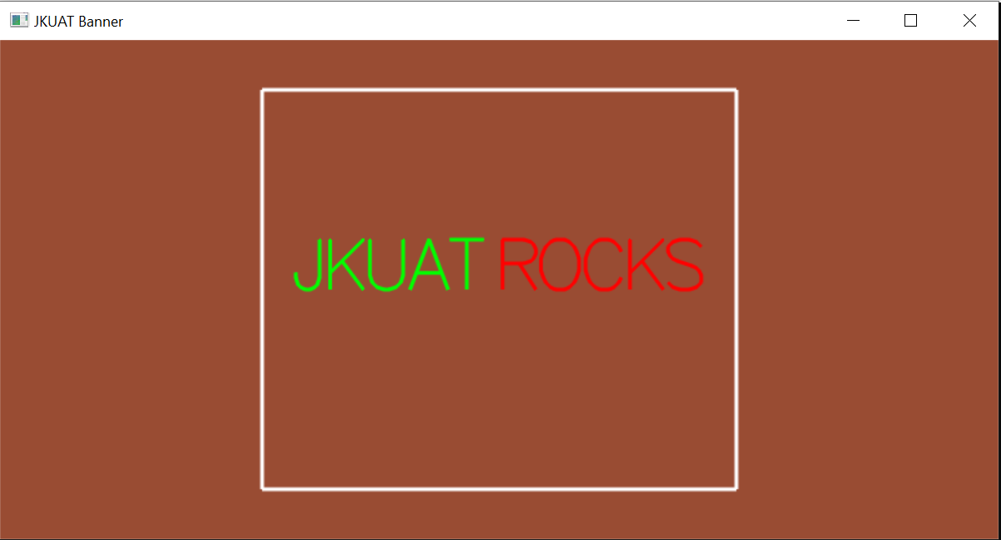
Increased size
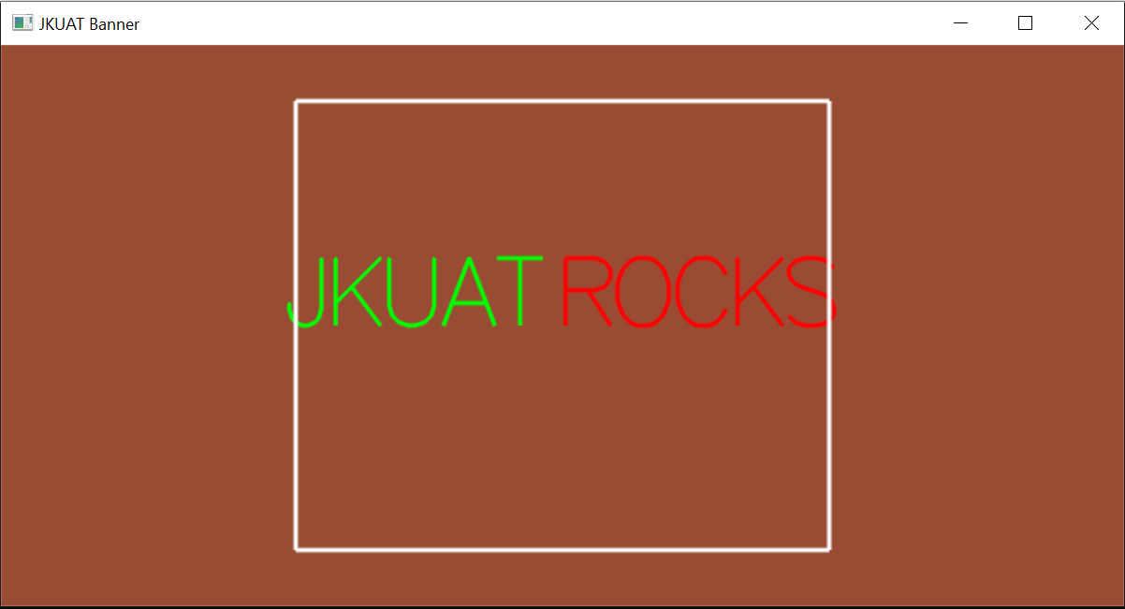
Reduced size
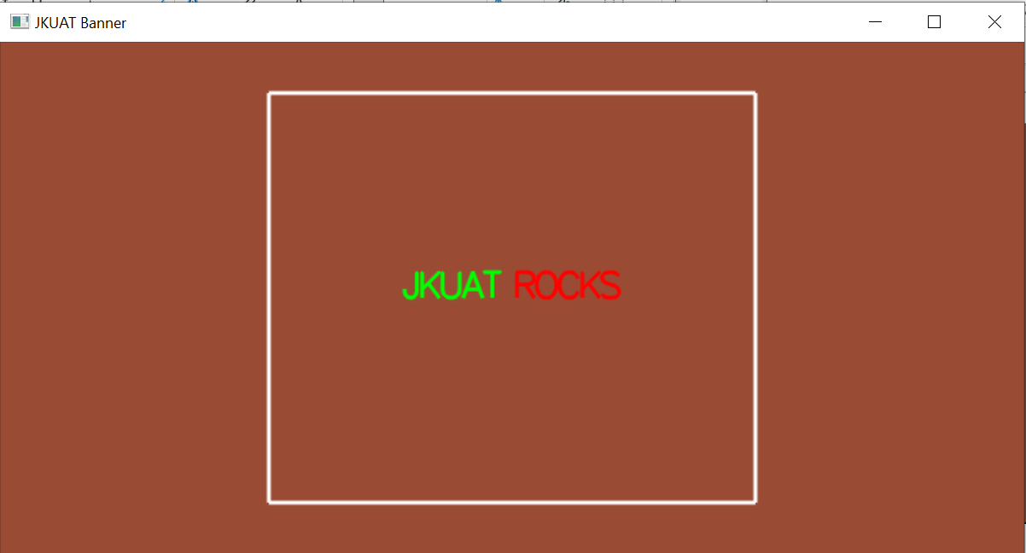

Python Implementation
Approach
The Python solution makes use of the Pillow (PIL) library to create and manipulate an image.
Key Components
a) Image Creation
A blank image was created using:
Image.new()
Background color set to brown
b) Font Handling
A TrueType font (arial.ttf) was loaded using:
ImageFont.truetype()
c) Text Measurement
To center the text:
draw.textlength() was used to calculate width
draw.textbbox() was used to calculate height
d) Centering Logic
The position was calculated using:
x = (image width−text width) / 2
​ y = (image height−text height) / 2
e) Rendering Colored Text
JKUAT is drawn in green
ROCKS is drawn in red after
This ensures correct spacing and alignment.
f) Output
The banner is displayed using image.show()
Coding Implementation
from PIL import Image, ImageDraw, ImageFont

def create_centered_banner():
# Setup the canvas
width, height = 1000, 400
brown_bg = (139, 69, 19)
image = Image.new("RGB", (width, height), brown_bg)
draw = ImageDraw.Draw(image)

# Load the font
try:
font = ImageFont.truetype("arial.ttf", 80)
except IOError:
font = ImageFont.load_default()

# Define the text and colors
text_part1 = "JKUAT "
text_part2 = "ROCKS"
full_text = text_part1 + text_part2

green = (0, 255, 0)
red = (255, 0, 0)

# Calculate total dimensions of the combined text
total_width = draw.textlength(full_text, font=font)

# Get the bounding box to find the true height of the text
# textbbox returns (left, top, right, bottom)
left, top, right, bottom = draw.textbbox((0, 0), full_text, font=font)
total_height = bottom - top

# Calculate perfectly centered X and Y coordinates
start_x = (width - total_width) / 2
start_y = (height - total_height) / 2

# Draw Part 1 (Green) at the calculated center-start position
draw.text((start_x, start_y), text_part1, font=font, fill=green)

# Get the width of Part 1
part1_width = draw.textlength(text_part1, font=font)

# Draw Part 2 (Red) immediately after Part 1
draw.text((start_x + part1_width, start_y), text_part2, font=font, fill=red)

# Display and save
image.show()
image.save("jkuat _banner.png")
print("Centered banner saved successfully!")

if __name__ == "__main__":
create_centered_banner()

Results
Default
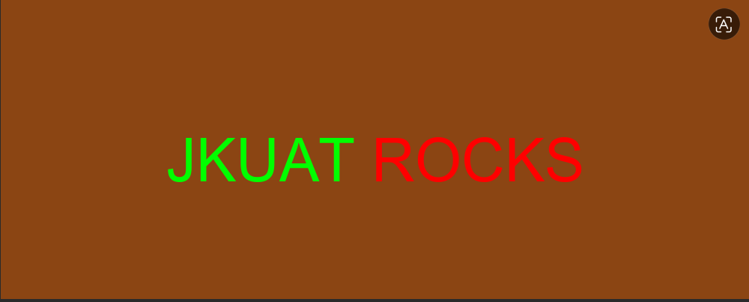
Increased Font

Reduced Font

Conclusion
The banner was successfully generated using both of these implementations. Python was able to provide simplicity and accurate text measurement, while OpenGL was able to facilitate interaction and real-time display. When you compare the two methods, you can see that OpenGL gives you a greater degree of authority and interactivity, but it also requires more work and a deeper understanding of technology. On the other hand, Python's Pillow module is better at making static pictures and is easier to use, especially when it comes to displaying text and laying things up.

Polygon Convex Decomposition Using the Rotational Method

Introduction
This section illustrates the geometric process of splitting a concave polygon (specifically a 4-pointed star) into smaller, purely convex polygons. This process, known as convex decomposition, is a necessary step for rendering complex shapes in graphics pipelines like OpenGL and for calculating physics collisions.

Code Implementation

Approach
The Python solution mirrors the mathematical logic of the Rotational Method but optimizes it using the 2D Cross Product. The algorithm iterates through the vertices of the polygon in a counter-clockwise direction, testing sets of three consecutive points to detect internal angles greater than 180 degrees. Upon detecting a concavity, the algorithm casts a ray to bisect the shape and generates two distinct polygons.

Key Components
- a) Cross Product Concavity Test A mathematical function cross_2d() evaluates the direction of the turn between three vertices. A negative result instantly flags the middle vertex as a concave "dent" without requiring costly trigonometric rotations.
- b) Ray-Line Intersection To calculate where to cut the polygon, the get_intersection() function tests an infinite ray (originating from the dent) against all other line segments (edges) of the polygon to find the exact floating-point coordinate of the collision.
- c) Splitting Logic Once the intersection point is established, the original list of vertices is cleanly divided into poly_a and poly_b, ensuring the new intersection coordinate is shared by both new shapes.
- d) Execution The algorithm is applied to an array of 8 coordinates representing the perimeter of a 4-pointed star.

Coding Implementation
C++
#include <iostream>
#include <vector>
#include <glm/glm.hpp>

// 2D Cross Product
float cross2D(glm::vec2 a, glm::vec2 b) {
return (a.x * b.y) - (a.y * b.x);
}

// Find where a ray hits a line segment
// Return true if there is a hit, and output the exact hitPoint
bool getIntersection(glm::vec2 rayOrigin, glm::vec2 rayDir, glm::vec2 edgeStart, glm::vec2 edgeEnd, glm::vec2& hitPoint) {
glm::vec2 edgeDir = edgeEnd - edgeStart;

float crossDir = cross2D(rayDir, edgeDir);

if (std::abs(crossDir) < 0.0001f) {
return false;
}

glm::vec2 originDiff = edgeStart - rayOrigin;

float t = cross2D(originDiff, edgeDir) / crossDir;
float u = cross2D(originDiff, rayDir) / crossDir;

if (t > 0.0001f && u >= 0.0f && u <= 1.0f) {
hitPoint = rayOrigin + (rayDir * t);
return true;
}
return false;
}

// The Splitting Function
void splitPolygon(const std::vector<glm::vec2>& poly) {
int n = poly.size();
if (n < 3) return;

for (int k = 0; k < n; ++k) {
int index_k = k;
int index_k1 = (k + 1) % n;
int index_k2 = (k + 2) % n;

glm::vec2 Vk = poly[index_k];
glm::vec2 Vk1 = poly[index_k1];
glm::vec2 Vk2 = poly[index_k2];

glm::vec2 edge1 = Vk1 - Vk;
glm::vec2 edge2 = Vk2 - Vk1;

if (cross2D(edge1, edge2) < -0.0001f) {
std::cout << "Concave Found at index " << index_k1 << " \n";

glm::vec2 rayOrigin = Vk1;
glm::vec2 rayDir = Vk1 - Vk;

glm::vec2 hitPoint;
int intersectedEdgeIndex = -1;

for (int i = 0; i < n; ++i) {

if (i == index_k || i == index_k1) continue;

glm::vec2 edgeStart = poly[i];
glm::vec2 edgeEnd = poly[(i + 1) % n];

if (getIntersection(rayOrigin, rayDir, edgeStart, edgeEnd, hitPoint)) {
intersectedEdgeIndex = i;
break;
}
}

if (intersectedEdgeIndex != -1) {
std::cout << "Ray hit edge starting at index " << intersectedEdgeIndex << " at point (" << hitPoint.x << ", " << hitPoint.y << ")\n";

std::vector<glm::vec2> polyA;
polyA.push_back(Vk1);
for (int i = index_k2; i != (intersectedEdgeIndex + 1) % n; i = (i + 1) % n) {
polyA.push_back(poly[i]);
}
polyA.push_back(hitPoint);

std::vector<glm::vec2> polyB;
polyB.push_back(hitPoint);
for (int i = (intersectedEdgeIndex + 1) % n; i != index_k2; i = (i + 1) % n) {
polyB.push_back(poly[i]);
}

std::cout << "\nPolygon A Vertices:\n";
for (auto p : polyA) std::cout << " (" << p.x << ", " << p.y << ")\n";

std::cout << "\nPolygon B Vertices:\n";
for (auto p : polyB) std::cout << " (" << p.x << ", " << p.y << ")\n";

return;
}
}
}
std::cout << "Polygon is fully convex!\n";
}

int main() {

std::vector<glm::vec2> starPerimeter = {
glm::vec2(0.0f, 0.5f),
glm::vec2(-0.15f, 0.15f),
glm::vec2(-0.5f, 0.0f),
glm::vec2(-0.15f,-0.15f),
glm::vec2(0.0f, -0.5f),
glm::vec2(0.15f,-0.15f),
glm::vec2(0.5f, 0.0f),
glm::vec2(0.15f, 0.15f)
};

std::cout << "Running Rotational Split on 4-Pointed Star...\n";
splitPolygon(starPerimeter);

return 0;
}
Python
def cross_2d(a, b):
"""Calculates the 2D cross product of two vectors."""
return (a[0] * b[1]) - (a[1] * b[0])

def get_intersection(ray_origin, ray_dir, edge_start, edge_end):
"""Finds the intersection point between a ray and a line segment."""
edge_dir = (edge_end[0] - edge_start[0], edge_end[1] - edge_start[1])
cross_dir = cross_2d(ray_dir, edge_dir)

# If cross_dir is close to 0, the lines are parallel
if abs(cross_dir) < 0.0001:
return False, None

origin_diff = (edge_start[0] - ray_origin[0], edge_start[1] - ray_origin[1])

# Calculate distance along the ray (t) and distance along the edge (u)
t = cross_2d(origin_diff, edge_dir) / cross_dir
u = cross_2d(origin_diff, ray_dir) / cross_dir

# t > 0 means it hits in front of the ray's origin
# 0 <= u <= 1 means it hits strictly within the bounds of the edge
if t > 0.0001 and 0.0 <= u <= 1.0:
hit_point = (ray_origin[0] + ray_dir[0] * t, ray_origin[1] + ray_dir[1] * t)
return True, hit_point

return False, None

def split_polygon(poly):
"""Detects concavities and splits the polygon into two new shapes."""
n = len(poly)
if n < 3:
return

for k in range(n):
index_k = k
index_k1 = (k + 1) % n
index_k2 = (k + 2) % n

vk = poly[index_k]
vk1 = poly[index_k1] # The potential dent
vk2 = poly[index_k2]

edge1 = (vk1[0] - vk[0], vk1[1] - vk[1])
edge2 = (vk2[0] - vk1[0], vk2[1] - vk1[1])

# Concavity Test using Cross Product
if cross_2d(edge1, edge2) < -0.0001:
print(f"--- Concavity Found at index {index_k1} ---")

ray_origin = vk1
ray_dir = (vk1[0] - vk[0], vk1[1] - vk[1])

intersected_edge_index = -1
hit_point = None

# Check every other edge to see where the ray hits
for i in range(n):
# Ignore edges immediately connected to the dent
if i == index_k or i == index_k1:
continue

edge_start = poly[i]
edge_end = poly[(i + 1) % n]

hit, point = get_intersection(ray_origin, ray_dir, edge_start, edge_end)
if hit:
intersected_edge_index = i
hit_point = point
break

if intersected_edge_index != -1:
print(f"Ray hit edge starting at index {intersected_edge_index} at point ({hit_point[0]:.4f}, {hit_point[1]:.4f})")

# Build Polygon A
poly_a = [vk1]
curr_idx = index_k2
while curr_idx != (intersected_edge_index + 1) % n:
poly_a.append(poly[curr_idx])
curr_idx = (curr_idx + 1) % n
poly_a.append(hit_point)

# Build Polygon B
poly_b = [hit_point]
curr_idx = (intersected_edge_index + 1) % n
while curr_idx != index_k2:
poly_b.append(poly[curr_idx])
curr_idx = (curr_idx + 1) % n

# Print the results
print("\nPolygon A Vertices:")
for p in poly_a:
print(f" ({p[0]:.4f}, {p[1]:.4f})")

print("\nPolygon B Vertices:")
for p in poly_b:
print(f" ({p[0]:.4f}, {p[1]:.4f})")

return # Stop after the first successful split

print("Polygon is fully convex!")

if __name__ == "__main__":
# Define the 4-Pointed Star (Counter-clockwise perimeter)
star_perimeter = [
( 0.0, 0.5), # 0: Top tip
(-0.15, 0.15), # 1: Top-Left Dent
(-0.5, 0.0), # 2: Left tip
(-0.15, -0.15), # 3: Bottom-Left Dent
( 0.0, -0.5), # 4: Bottom tip
( 0.15, -0.15), # 5: Bottom-Right Dent
( 0.5, 0.0), # 6: Right tip
( 0.15, 0.15) # 7: Top-Right Dent
]

print("Running Rotational Split on 4-Pointed Star...\n")
split_polygon(star_perimeter)

Results
When the Python implementation is executed on the 4-pointed star dataset, the algorithm successfully bypasses the top tip and immediately identifies the top-left indentation as a concave vertex (Index 1).
The output logs correctly demonstrate the ray traversing the interior of the shape and severing the bottom-right edge (Index 4), returning the exact floating-point coordinate of the bisection. The initial 8-vertex array is cleanly divided into two entirely new sub-polygons (Polygon A and Polygon B).

Conclusion
The geometric splitting operation was successfully executed using the Python implementation. By utilizing the 2D Cross Product over traditional trigonometric rotation methods, the code achieves an efficient and precise detection of concavities. This approach verifies that complex geometries can be programmatically subdivided into simpler convex datasets, perfectly preparing them for hardware-accelerated rendering pipelines or spatial physics calculations.

